# https://upload.wikimedia.org/wikipedia/en/f/f1/Capital_University%2C_Jharkhand_logo.png

# CAPITAL UNIVERSITY - KODERMA

HVDC ASSIGNMENT

Name : Arshad Nazir

Electrical and Electronics Engineering

Signature:

Date :

Q1 Ans:

Application of HVDC Transmission

* Connecting of remote generation

Some energy sources, such as hydro and solar power, are often located hundreds or thousands kilometers away from the load centers. HVDC will reliably deliver electricity generated from mountain tops, deserts and seas across vast distances with low losses.

* Interconnecting Grid

Connecting AC grids is done for stabilization purposes and to allow energy trading. During some specific circumstances, the connection has to be done using HVDC, for example when the grids have different frequencies or when the connection has to go long distances over water and AC cables cannot be used because of the high losses.

* Connecting Offshore Wind

Wind parks are often placed far out at sea, because the wind conditions are more advantageous there. If the distance to the grid on land exceeds a certain stretch, the only possible solution is HVDC – due to the technology’s low losses.

* DC Links In AC Grids

HVDC links within an AC grid can be successfully utilized to strengthen the entire transmission grid, especially under demanding load conditions and during system disturbances. Transmission capacity will improve and bottlenecks be dissolved.

* Connecting Remote Loads

Islands and remotely located mines often have the disadvantage of a weak surrounding AC grid. Feeding power into the grid with an HVDC link, improves the stability and even prevents black-outs.

Q2 Ans:

Different Types Of Transmission Systems

Single phase AC system

* Single phase, two wires
* Single phase, two wires with midpoint earthed
* Single phase, three wires

Two phase AC system

* Two-phase, three wires
* Two-phase, four wires

Three phase AC system

* Three-phase, three wires
* Three-phase, four wires

DC system

* DC two wires
* DC two wires with midpoint earthed
* DC three wires

Q3 Ans:

The AC transmission system is used for short distance transmission. The DC transmission is used for transmission of electric power for long distances. The AC transmission lines interfere the nearby communication lines. The DC transmission lines do not interfere the communication lines.The AC transmission lines have dielectric losses.The DC transmission lines do not have dielectric losses.

Q4 Ans:

Advantages of DC Transmission

DC transmission requires less conductor material than AC transmission as only two wire are required for the power transmission through DC system.

DC transmission lines are free from the skin effect. Therefore, the entire cross-section of the line conductor is utilised, hence the effect resistance of the line is small.

There is no capacitance in the DC transmission. Therefore, there is no power loss due to the charging current.

There is no inductance, phase displacement, and surge problems in the DC transmission.

Q5 Ans:

The disadvantages of DC transmission are

Electric power cannot be generated at high DC voltage because of commutation problems.

DC switchgears have their own limitations and they are also expensive than the AC one.

DC voltage cannot be directly step-up or step-down for transmitting the power at high voltages and for distributing it at low voltages.

It requires extra equipment such rectifier and inverter, etc. which increases the cost of transmission.

Q6 Ans:

The high voltage dc links may be classified into

Monopolar Link:

The only one conductor used in this type of HVDC transmission system. The most negative terminal is preferred to transfer to reduce the corona effect and the ground will be taken as the current return path. But sometimes a metallic return path also considers. The earthing of poles is done by earth electrodes located about 15 to 55 km away from the respective terminal station. However, the earth terminal cannot be a perfect return path for the loads, since the monopolar link is not used in the present days.

Bipolar Link:

It has two parallel conductors, operates at one positive polarity and the other operates at negative polarity. Each terminal has sets of converters of identical ratings in series in DC lines which is used to convert AC to DC. The midpoints of converters station are earthen via the electrode. The voltage between the conductors is equal to two times the voltage between either of the conductors and earth.

HomoPolar Link:

It is an updated version of the monopolar link. A homopolar link has two conductors which have a negative polarity and the current return will be taken as a metallic wire or ground. Failure on one conductor and other conductor operates as a monopolar link. The most negative polarity is preferred to reduce transmission losses.

Q8 Ans:

The factors to be considered are (i) cost (ii)technical performance, and (iii) reliability.

Generally, the last two factors are considered as constraints to be met and the minimum cost option is selected among various alternatives that meet the specification on technical performance and reliability.

In the DC and AC alternatives for the same level of system security and reliability are likely to have the same power carrying capability. Thus the cost comparison would form the basis for the selection of the DC (or AC) alternative, if the requirements regarding technical performance are not critical.

Q10 Ans:

A DC circuit breaker is an Over Current Protection Devices that protects electrical devices operating with DC and contains additional arc-extinguishing measures. DC circuit breakers are a relatively new technology to most homeowners since most devices used in a house work with AC and AC circuit breakers.

An electrical power bar for example has a built-in circuit breaker. When too many things are using the power from one source, it shuts off the power, thereby protecting the electrical devices plugged into the bar.

These are often used on desktop computers. A sudden power surge can destroy a CPU. A power bar with a built-in circuit breaker protects the CPU and everything else attached to the bar.

Q12 Ans:

Some common power devices are the power MOSFET, power diode, thyristor, and IGBT. The power diode and power MOSFET operate on similar principles to their low-power counterparts, but are able to carry a larger amount of current and are typically able to withstand a larger reverse-bias voltage in the off-state.

Q13 Ans:

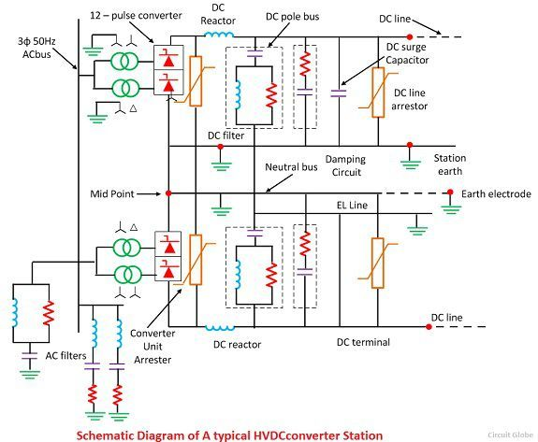

Q14 Ans:

In contrast to AC systems, designing and operating multi-terminal HVDC systems is complex, Controlling power flow in such systems requires continuous communication between all terminals as power flow must be actively regulated by the control system instead of by the inherent properties of the transmission line.

Grounding HVDC transmission involves a complex and difficult installation, as it is necessary to construct a reliable and permanent contact to the Earth for proper operation and to eliminate the possible creation of a dangerous “step voltage.”

Q17 Ans:

Application

1. Interconnection of two AC systems

DC link is an economical option than the AC link to interconnect two AC systems. This system is more effective, efficient and technically superior compared to the AC link.

The biggest advantage is the there is no effect of frequency in the DC link. And the frequency disturbance of one system does not transfer to other systems.

It does not affect the transient stability and there is no change in the short circuit levels of both the systems.

1. Long-distance power transmission line

This is the main purpose to use the HVDC system. Because in the HVAC system, the length of a line is the biggest constraint. The length of the line cannot more than a certain length to keep control of the thermal effect of the conductor. And it needs an intermediate substation every 300 km of line.

1. Multi-terminal HVDC interconnection

The frequency does not affect in DC system. Therefore, if the frequency is not the same, then also these systems can connect with the HVDC link.

Three or more AC systems can be interconnected asynchronous using a multi-terminal HVDC system. Due to this, bulk power can be transferred.

1. Underground or submarine cable transmission

In the AC system, it is difficult to transmit power through underground cable or submarine cable because of the temperature rise due to the charging current.

This will limit the length of the line. But this problem solved in the HVDC line as an absence of the charging current.

Therefore, it is easy to implement the underground and submarine cable with the HVDC transmission line.

1. Parallel AC and DC link

DC link operates with the parallel to the existing AC line. In this way, more amount of power can transmit.

Due to this, there is a decrease in the fault level and an increase in the stability of the system.

Q19 Ans:

An electric power transmission system that uses alternating current to transmit the power is called the AC transmission system. An electric power transmission system which transmits the electric power in the form of DC supply, is called the DC transmission system.

The construction of AC transmission lines is more complicated.The construction of DC transmission lines is less complicated.

In the AC transmission system, electric power can be generated easily at high voltages.In the DC transmission system, electric power cannot easily be generated at high voltage due to commutation problems.

For the AC transmission, three conductors are required, (for red phase, yellow phase and blue phase).For DC transmission, only two conductors (positive and negative) are required.

In the AC transmission, transformer is used for stepping-up or down the voltage In DC transmission, the transformer cannot be used as the transformer does not work with the DC supply.

The AC transmission requires more insulation material due to more number of conductors. The DC transmission requires less insulation material due to less number of conductors.

Q20 Ans:

The controllability of a current-flow through HVDC rectifiers and inverters, their application in connecting unsynchronized networks, and their applications in efficient submarine cables mean that HVDC interconnectors are often used at national or regional boundaries for the exchange of power (in North America, HVDC connections divide much of Canada and the United States into several electrical regions that cross national borders, although the purpose of these connections is still to connect unsynchronized AC grids to each other). Offshore windfarms also require undersea cables, and their turbines are unsynchronized. In very long-distance connections between two locations, such as power transmission from a large hydroelectric power plant at a remote site to an urban area, HVDC transmission systems may appropriately be used; several schemes of these kind have been built. For interconnectors to Siberia, Canada, India, and the Scandinavian North, the decreased line-costs of HVDC also make it applicable,

AC network interconnectors

AC transmission lines can interconnect only synchronized AC networks with the same frequency with limits on the allowable phase difference between the two ends of the line. Many areas that wish to share power have unsynchronized networks. The power grids of the UK, Northern Europe and continental Europe are not united into a single synchronized network. Japan has 50 Hz and 60 Hz networks.

A generator connected to a long AC transmission line may become unstable and fall out of synchronization with a distant AC power system. An HVDC transmission link may make it economically feasible to use remote generation sites. Wind farms located off-shore may use HVDC systems to collect power from multiple unsynchronized generators for transmission to the shore by an underwater cable.

In general, however, an HVDC power line will interconnect two AC regions of the power-distribution grid. Machinery to convert between AC and DC power adds a considerable cost in power transmission. The conversion from AC to DC is known as rectification, and from DC to AC as inversion. Above a certain break-even distance (about 50 km for submarine cables, and perhaps 600–800 km for overhead cables), the lower cost of the HVDC electrical conductors outweighs the cost of the electronics.

The conversion electronics also present an opportunity to effectively manage the power grid by means of controlling the magnitude and direction of power flow. An additional advantage of the existence of HVDC links, therefore, is potential increased stability in the transmission grid.

Q23 Ans:

DC equipment

The direct current equipment often includes a coil (called a reactor) that adds inductance in series with the DC line to help smooth the direct current. The inductance typically amounts to between 0.1 H and 1 H. The smoothing reactor can have either an air-core or an iron-core. Iron-core coils look like oil-filled high voltage transformers. Air-core smoothing coils resemble, but are considerably larger than, carrier frequency choke coils in high voltage transmission lines and are supported by insulators. Air coils have the advantage of generating less acoustical noise than iron-core coils, they eliminate the potential environmental hazard of spilled oil, and they do not saturate under transient high current fault conditions. This part of the plant will also contain instruments for measurement of direct current and voltage.

Special direct current filters are used to eliminate high frequency interference. Such filters are required if the transmission line will use power-line communication techniques for communication and control, or if the overhead line will run through populated areas. These filters can be passive LC filters or active filters, consisting of an amplifier coupled through transformers and protection capacitors, which gives a signal out of phase to the interference signal on the line, thereby cancelling it.

Converter transformer

The converter transformers step up the voltage of the AC supply network. Using a star-to-delta or “wye-delta” connection of the transformer windings, the converter can operate with 12 pulses for each cycle in the AC supply, which eliminates numerous harmonic current components. The insulation of the transformer windings must be specially designed to withstand a large DC potential to earth. Converter transformers can be built as large as 300 Mega volt amperes (MW) as a single unit. It is impractical to transport larger transformers, so when larger ratings are required, several individual transformers are connected together. Either two three-phase units or three single-phase units can be used. With the latter variant only one type of transformer is used, making the supply of a spare transformer more economical.

Converter transformers operate with high flux Power Steps In the Four Steps of the Converter per cycle, and so produce more acoustic noise than normal three-phase power transformers. This effect should be considered in the siting of an HVDC converter station. Noise-reducing enclosures may be applied.

Reactive power

When line commutated converters are used, the converter station will require between 40% and 60% of its power rating as reactive power. This can be provided by banks of switched capacitors or by synchronous condensers, or if a suitable power generating station is located close to the static inverter plant, the generators in the power station. The demand for reactive power can be reduced if the converter transformers have on-load tap changers with a sufficient range of taps for AC voltage control. Some of the reactive power requirement can be supplied in the harmonic filter components.

Voltage sourced converters can generate or absorb reactive as well as real power, and additional reactive power equipment is generally not needed.

Harmonic filters

Harmonic filters are necessary for the elimination of the harmonic waves and for the production of the reactive power at line commutated converter stations.

Voltage sourced converters generally produce lower intensity harmonics than line commutated converters. As a result, harmonic filters are generally smaller or may be omitted altogether.

Beside the harmonic filters, equipment is also provided to eliminate spurious signals in the frequency range of power-line carrier equipment in the range of 30 kHz to 500 kHz. These filters are usually near the alternating current terminal of the static inverter transformer. They consist of a coil which passes the load current, with a parallel capacitor to form a resonant circuit.

AC switchgear

The three-phase alternating current switch gear of a converter station is similar to that of an AC substation. It will contain circuit breakers for overcurrent protection of the converter transformers, isolating switches, grounding switches, and instrument transformers for control, measurement and protection. The station will also have lightning arresters for protection of the AC equipment from lightning surges on the AC system.

Q25 Ans:

Pulse number is defined as the number of pulses in the dc output voltage within one time period of the ac source voltage. In high-power applications, ac–dc converters based on the concept of multipulse, namely, 12, 18, 24, 30, 36, 48 pulses are used to reduce the harmonics in ac supply currents.

Q26 Ans:

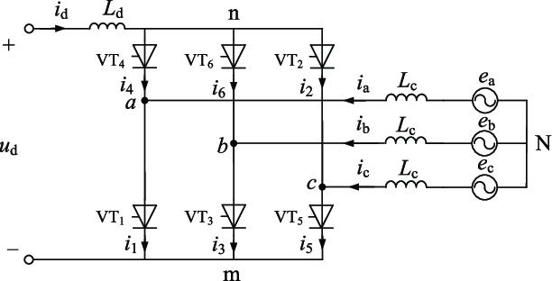

**6 pulse Graetz bridge circuit**

Q28 Ans:

Choice of Converter configuration

In general converter configuration can be selected by the basic commutation group and the no. of such groups connected in series and parallel. Commutation group means set of valves in which only one valve conducts at a time.

Q29 Ans:

The peak inverse voltage is either the specified maximum voltage that a diode rectifier can block, or, alternatively, the maximum voltage that a rectifier needs to block in a given circuit. The peak inverse voltage rises with rise in temperature and decrease with decrease in temperature.

Q31 Ans:

A Twelve pulse converter, for higher voltage applications, is obtained by intercon­necting two six pulse converters, as shown in Fig. The input voltage to the converters should have a phase difference of 30°, which can be achieved in two ways.

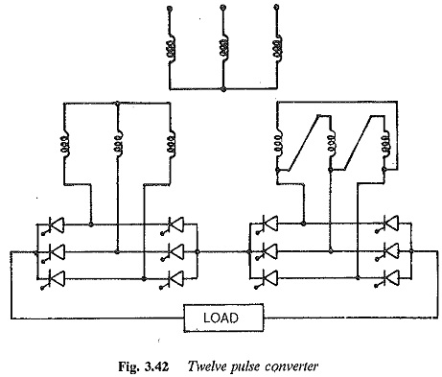

The primary of one transformer is connected in star and that of the other in delta. The converter transformer has two secondaries, one of which is connected in star and the other in delta.

Q32 Ans:

At any instant, two valves are conducting in the bridge, one from the upper Commutation group and the second from the lower commutation group. The firing of the Next valve in a particular group results in the turning OFF of the valve that is already Conducting. The valves are numbered in the sequence in which they are fired. Each valve Conducts for 120degree And the interval between consecutive firing pulse is 60degree In steady state.

Q33 Ans:

In electrical engineering, a synchronous condenser (sometimes called a syncon, synchronous capacitor or synchronous compensator) is a DC-excited synchronous motor, whose shaft is not connected to anything but spins freely. Its purpose is not to convert electric power to mechanical power or vice versa, but to adjust conditions on the electric power transmission grid. Its field is controlled by a voltage regulator to either generate or absorb reactive power as needed to adjust the grid’s voltage, or to improve power factor. The condenser’s installation and operation are identical to large electric motors and generators.

Q35 Ans:

A tap changer is a mechanism in transformers which allows for variable turn ratios to be selected in distinct steps. This is done by connecting to a number of access points known as taps along either the primary or secondary winding.Q37 Firing Angle Control: Firing angle control can be used in applications like controlling the speed of fan motors, controlling the intensity of a bulb, by controlling the application of power to the SCR. The firing angle control is achieved by varying the time of application of Gate pulses to the SCR.

Q37 Ans:

Firing Angle Control: Firing angle control can be used in applications like controlling the speed of fan motors, controlling the intensity of a bulb, by controlling the application of power to the SCR. The firing angle control is achieved by varying the time of application of Gate pulses to the SCR.

The major advantage of a hvdc link is rapid controllability of transmitted power through the control of firing angles of the converters. Modern converter controls are not only fast, but also very reliable and they are used for protection against line and converter faults. Principles of dc link control.

Q39 Ans:

A novel equidistant pulse control scheme is described and tested which is simple, economic, elegant and tends to combine the good features of the presently available firing control schemes. A simple protection circuit is developed for protection of the converter against over current and fault current.

Q40 Ans:

AC circuit breakers (CB) with DC switches are used. These are cheaper than DC circuit breakers. If the fault occurs in a DC line, the AC circuit breaker opens the line from the AC side and the DC switch will isolate the faulty line. This protection scheme can be applied to a point-to-point HVDC transmission system.

Q42 Ans:

Tap changers exist in two primary types, no-load tap changers (NLTC), which must be de-energized before the turn ratio is adjusted, and on-load tap changers (OLTC), which may adjust their turn ratio during operation. The tap selection on any tap changer may be made via an automatic system, as is often the case for OLTC, or a manual tap changer, which is more common for NLTC. Automatic tap changers can be placed on a lower or higher voltage winding, but for high-power generation and transmission applications, automatic tap changers are often placed on the higher voltage (lower current) transformer winding for easy access and to minimize the current load during operation.

Q43 Ans:

On-load tap changer (OLTC), also known as On-circuit tap changer (OCTC), is a tap changer in applications where a supply interruption during a tap change is unacceptable, the transformer is often fitted with a more expensive and complex on load tap changing mechanism. On load tap changers may be generally classified as either mechanical, electronically assisted, or fully electronic.

These systems usually possess 33 taps (one at centre “Rated” tap and sixteen to increase and decrease the turn ratio) and allow for ±10% variation (each step providing 0.625% variation) from the nominal transformer rating which, in turn, allows for stepped voltage regulation of the output.

Q46 Ans:

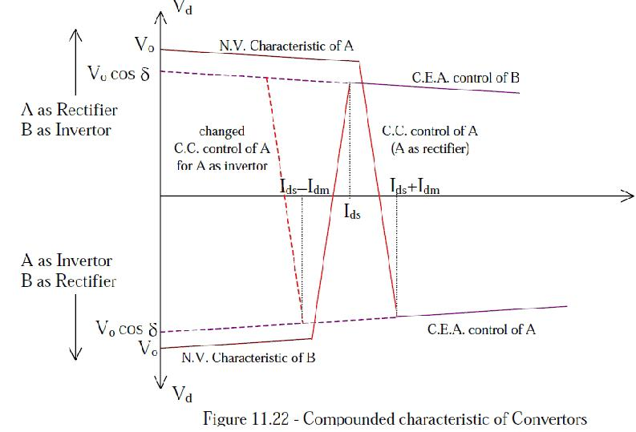

Q47 Ans:

In an electric power system, a harmonic of a voltage or current waveform is a sinusoidal wave whose frequency is an integer multiple of the fundamental frequency. Harmonic frequencies are produced by the action of non-linear loads such as rectifiers, discharge lighting, or saturated electric machines. They are a frequent cause of power quality problems and can result in increased equipment and conductor heating, misfiring in variable speed drives, and torque pulsations in motors and generators.

Harmonics are usually classified by two different criteria: the type of signal (voltage or current), and the order of the harmonic (even, odd, triplen, or non-triplen odd); in a three-phase system, they can be further classified according to their phase sequence (positive, negative, zero).

Q48 Ans:

Harmonics are created by electronic equipment with nonlinear loads drawing in current in abrupt short pulses. The short pulses cause distorted current waveforms, which in turn cause harmonic currents to flow back into other parts of the power system.

Q49 Ans:

HVDC converter produces a large number of harmonics, and these harmonics impact the surrounding environment. So it is need to reduce them effectively.

According to the characteristic, it puts forward corresponding suppression measures. AC filter can absorb harmonic and reduce the harmonic at the connection point, so ac filter is an effective measure, in addition, it also takes into account the reactive power compensation need. Because of the simple structure, reliable operation and easy maintenance, ac filter has been widely used.

Q51 Ans:

AC filters are widely used to restrain the AC side harmonics and to compensate for reactive power. The design of the AC filters has to satisfy the requirements of harmonic performance and reactive power compensation for the various operation modes.

Q52 Ans:

The line boundary of high voltage direct current (HVDC) system is composed of dc filters and smoothing reactor, which has attenuation to high frequency signals and can be used to propose novel line protections.

DC EMI Filters allow DC and low-frequency currents to pass through while blocking harmful high-frequency currents. This allows devices to work correctly by diverting unnecessary noise.

Q54 Ans:

An interference is that which modifies a signal in a disruptive manner, as it travels along a communication channel between its source and receiver. The term is often used to refer to the addition of unwanted signals to a useful signal. Common examples include:

Electromagnetic interference (EMI)

Co-channel interference (CCI), also known as crosstalk

Adjacent-channel interference (ACI)

Intersymbol interference (ISI)

Inter-carrier interference (ICI), caused by doppler shift in OFDM modulation (multitone modulation).

Common-mode interference (CMI)

Conducted interference

Q55 Ans:

Total harmonic distortion, or THD, is one way to gauge power supply quality. It indicates how much of a harmonic component the voltage and current waveforms contain, and it serves as an indicator of the extent of the waveform distortion that is caused as a result.

Q56 Ans:

**Ways to avoid interference**

**Transmit in different places**

Two transmitters can use the same frequency at the same time if they are separated.

**Transmit at different frequencies**

Two transmitters can cover the same area and transmit at the same time if they use different frequencies.

**Transmit at different times.**

Q57 Ans:

Telephone Influence Factor

A measure of the interference of power-line harmonics with telephone lines, which is derived by weighting the terms in the mathematical expression for the total harmonic distortion of the power-line voltage.

Q58 Ans:

Types of DC Filter Circuits

Capacitor filter.

Choke input filter.

Capacitor input or π – filter.

Types of AC Filter

Tuned filter.

Damped filter.

Q59 Ans:

An ideal single-tuned filter is said to be tuned on the frequency that makes its inductive and capacitive reactance to be equal[5]. The quality factor(Q) of filter determines the sharpness of tuning, and in this respect filters may be either a high or a low Q type.